New book by Martin Allen and Patrick Ainley
Publication date 13/02/13
ISBN 978-0-9575538-0-4. Available as hard copy or Ebook

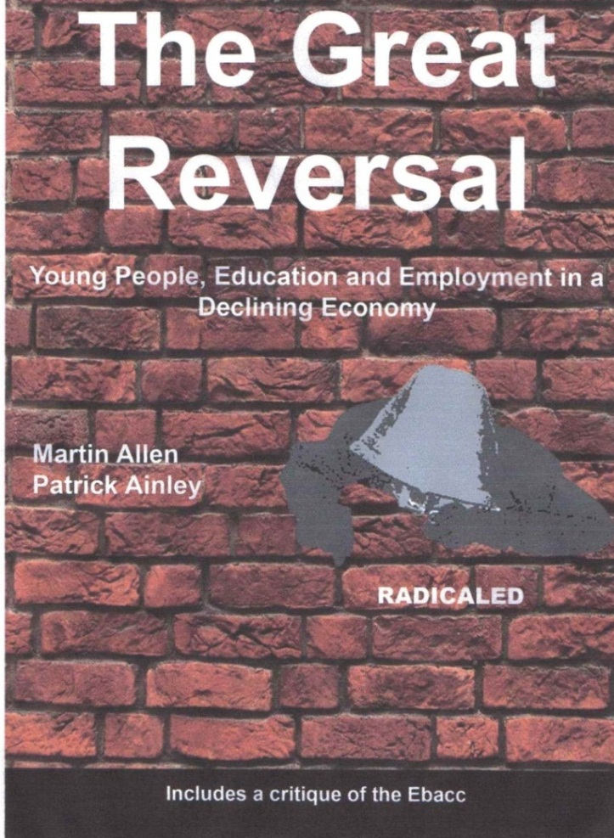

Developing the arguments put forward in their previous books Education make you fick, innit? and Lost Generation? New strategies for youth and education, Allen and Ainley provide a chilling analysis of the employment difficulties facing young people. A stinging attack on the Coalition’s education policy, The Great Reversal argues we can’t simply educate our way out of recession. Real alternatives are needed.
Available from on-line distributors and from www.radicaled.wordpress.com 124 pp. £4.99 Hard copy, £1.99 Ebook (special rates for multiple purchase)

